Baldwin Whitehall Soccer Association
Under 6s Program

Designed By Thomas Skinner (BA Hons), Youth Elite Soccer Coach
Forwarded by: Kris Schemm and Seth Madjerich

Contents Page

Introduction to Baldwin Whitehall Soccer Association

Aims for the BWSA Under 6s Program

Baldwin Whitehall Soccer Association Philosophy

Baldwin Whitehall Soccer Association Long Term Player Development

Basic Soccer Skills Coaching Points

Organisation of Under 6s Group Practice

Scheme of Work Outline

Coaching Tips

Feedback Form

Introduction to Baldwin Whitehall Soccer Association
Baldwin Whitehall Soccer Association (BWSA) was established in 1982 and is located in the heart of Baldwin, Allegheny County, Pennsylvania. The Association is a friendly, welcoming and hardworking association, who maintain a committed ethos to helping develop young players to reach their full potential in the game.
From board members, coaches to volunteers, we all work together to provide the best possible environment to nurture and improve the playing experience our players. We believe that in order for this to happen our players need to be able to participate in a fun, safe and methodological learning environment. The Association is continually working to develop our facilities, equipment, coaches and the experience everyone involved with the Association is exposed to.
We have a number of playing fields that we use throughout each season…..
- Main Field: Colewood Park (Located In between Colewood Drive and Overland Trail)
- Whitehall Elementary School (Located on 4900 Curry Road, Pittsburgh, 15236)
- McAnnutly Elementary School (Located 5151 McAnnulty Road, Pittsburgh, PA 15236)

For information about Baldwin Whitehall Soccer Association please visit use on: http://www.bwsasoccer.com/index.html
Or find us on Facebook: https://www.facebook.com/baldwin.bwsa?fref=ts

Aims for the BWSA Under 6s Program
This program contains of a new ten-week programme of progressive session plans for players under 6 years old. Each session plan has distinct activities/games that will cater for players of different soccer experiences, from being new in the game to developing towards a competitive level. Importantly this program has been developed to deliver the ‘aims’ that BWSA feel necessary to grow the game in the area, by using an enjoyable and game centred approach to coaching soccer.
Aims of the program: The purpose of the BSWA U6 Soccer program is to achieve the following aims...
- For players to develop their technical, social, physical and psychological abilities involved in playing soccer.
- For players to develop personally and socially in soccer.
- For players to feel valued and feel part of a team.
- For players to continue to play soccer beyond this age group.
- For new players to be introduced to the game and for all players to enjoy playing in a fun learning environment.
Our sessions aim to maximize the learning time of the players. This is done by grouping the players into their teams and giving them a circuit style training session, so that they can rotate around stations and learn about the session’s topic in different environments. This enables the coaches to select players who are struggling in their team and give them specific coaching points (either individually or as a group) to help overcome the barriers to their learning. Once they have developed their understanding of the skills they are learning about, they can be re-introduced back into the activity for an opportunity to showcase their understanding and ability in the game. The Under 6 program is designed to help develop each player’s competence, confidence, performance, character, creativity, and understanding of soccer.

Baldwin Whitehall Soccer Association Philosophy

At Baldwin Whitehall Soccer Association we aim to create a culture and values that underpin the Association’s DNA. We feel that if everyone is on the same page and everyone buys into what we as an Association are trying to do, it becomes much more powerful and effective in moving our players forward.
Our Philosophy at Baldwin Whitehall Soccer Association is…….
“We want to develop a generation of players, who are creative in seeking their own answers when faced with challenge on the pitch. We also want to develop players, who are comfortable with the ball at their feet to be able to creatively express themselves individually, in addition to being part of a team in retaining and maintaining possession of the ball.”
In order for the first part of the philosophy (being creative) to happen, our coaches aim to include the following questions about the week’s theme in our sessions…..
Question | What does it mean | Example
What? | What does the theme mean? What are the different ways this can be done? | Dribbling: A player maneuvering the ball whilst maintaining control in any given direction, while avoiding opposition players’ attempts to prevent this occurring.
Who? | Who is involved? Which player/s perform this aspect of the game. | Primarily the player in possession of the ball, however he/she needs teammates to create space behind the opposition players.
How? | How can you do this well? How can you be creative with this technique, skill, strategy? | Be creative with skills, tricks and feints to unbalance the opposition player and exploit the space behind the opposition player. Also practice them as much as possible.
When? | When does it’s happen in the game? | When there is space behind an opposition player.
Where? | Where on the pitch does it happen most frequently? | In 1 v 1, 1 v 2, 1 v3 etc situations. Generally, when a player is moving forward with the ball into the opposition’s half.

To help with the second part of the philosophy, our coaches aim to use different coaching styles, methods and processes to help players reach their full potential in training and matches. These can be Guided Discovery, Questions and Answers, Self-Check, Reciprocal etc. However there is a common ‘Coaching Process’ all our coaches use (See next page).

General Coaching Process at Baldwin Whitehall Soccer Association

Coach watches the players performing the activity/task.
Coach observes the play and allow to move on if possible.
Coach may stop the practice as a group or for the individual.

Coach identifies poor technique or application of a skill.

Coach allows players to rehearse the correct application of the skill/technique.
Coach fixes the problem

Coach may use:
- Demonstrations
- Instructions
- Questions and Answer
- Different coaching styles (depending on the individual)

Baldwin Whitehall Soccer Association Long Term Player Development Model
Baldwin Whitehall Soccer Association is committed to ensuring that our players grow and develop to their full potential in the game. In order to do this, we have adopted the Four Corner model approach developed by the Football Association (English national governing body for Soccer), as it outlines four key factors that should be considered in coaching youth soccer. The model’s four corners consist of Technical, Psychological, Physical and Social (See below).
Thinking and Doing
Doing

Discussing and Doing

Doing

Each player’s development pathway in the game will be unique and diverse, at Baldwin Whitehall Soccer Association we realize that some players require minimal support in some corners and others will require more or specific support in more of corners.

It is important for coaches to understand that each aspect of the four corners does not exist in isolation, all are linked to each other. The next page gives a brief description of what each of the four corner model involved in relation to the Under 8 Baldwin Whitehall Soccer Association players.

- Technical: The application of the skills and techniques, the players perform during the session. Training and matches need to be appropriate to meet the individual needs of the group, including varying the activity progressions and positional roles. The application of skills can be affected by the decision making (psychological), physical development of the player and their peers in the group (social). This highlights the link and the need to develop all four corners, not just the technical corner.
- Psychological: The development of the thinking process the players are exposed to during sessions. It involves independent thinking to find solutions and understanding of how to problem solve during soccer. This can be influenced by the personality, learning process, experience, confidence and behaviour traits of the individual player.
- Physical: The physical development of the player linked to their chronological and biological age. These can affect by the frequency, intensity, duration of the activities and the development of skills. E.g. an Under 8 player can have the Biological age (Physically) of an Under 10 player, however their development of their Coordination skills can be weaker than players of the same chronological age.
- Social: The influence of life at home, school, community and peer groups. This corner can impacted by peer pressure, relationships with others and the player’s lifestyle.
The table below shows different aspects of each corner that Baldwin Whitehall Soccer Association coaches must consider to develop our Under 8 Players long term.

Technical | Psychological | Physical | Social
- Basic techniques and skills  - Lots of repetition of techniques and skills  - Group practices  - Interchange of positions  - Invasion games | - Enthusiasm  - Imagination and Exploration  - Avoiding anxiety and boredom  - Progression introduction to mental skills  - Understanding of the game  - Creative Decision Making  - Confidence and self-esteem. | - ABCs (Agility, Balance, Co-ordination and Speed)  - C.P.K movements (Catching, Passing and Kicking)  - R.J.T Movements (Running, Jumping and Throwing).  - Motor Control, Multi-Skills | - Fun and enjoyment  - Support from peers, coaches, parents and the Association.  - Form relationships  - Safe environment  - Simple rules and ethics  - Individual and Group behavior

The next page demonstrates how the Four Corner Long Term Player Development Model might look during a session.

Activity | Diagram | Description | Coaching Points
Skills Corridor  Progressions:  -Add a Tagger for players to dribble and avoid.  - Make the Corridor smaller.  - Add obstacles for players to dribble around. | 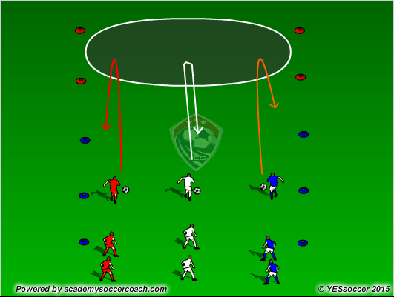 | - Players dribble through the corridor in groups of three. At the end of the corridor, the two end players turn off on the end cone while the middle player can turn off either side.  - Once players gain an understanding of the activity, The coach can motivate the players by telling them they are to undergo a series of challenges:  - Dribble through using as many parts of the foot as possible.  - Dribble through getting as many touches in-between the first a last set of cones.  - Dribble having as few touches as possible.  - Dribble through forwards/backwards/sideways  - Dribble in a Zig-Zag rather than a straight line.  - Freestyle (Players can dribbling perform any tricks they like.  - Relay Race: Dribblers dribble through the corridor in a relay race (Turns in between red cones and go back). See second diagram. | • Head up (Looking for space and other players)  • Light and on toes (like a boxer)  • Use all different parts of the feet (inside and laces mostly, may use outside)  • Keep the ball close but out of feet (small touches)  • Use both feet to dribble  • Change pace  • Dribble into space  • Always be moving.
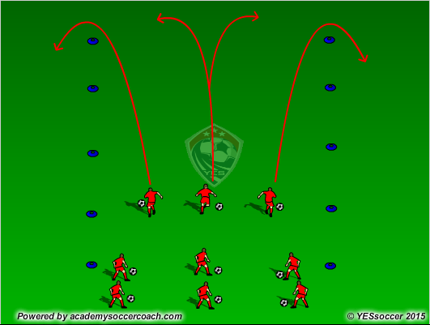
Where the four corner model fits in with the Skills Corridor……
Technical
- Head up (Look for space)
- Be light on tip toes (Easier to move with the ball).
- Keep the ball close and under control (small touches)
- Use different parts of the foot to dribble.
- Use both feet to dribble.
- Change pace

Psychological
- Players looking and identifying where free space is
- Players should be creative with the movements, tricks and feints.
- Players decide when to change the pace of their dribble.
- Players will evaluate their own performance and find ways to improve.

Physical
- Players will use coordination and balance to effectively dribble the ball with different parts of their feet and perform tricks/feints.
- Players will use changes of speed and direction depending on the challenges or if the practice becomes opposed.

Social
- Players understand the importance of everyone being involved in the game.
- Players may discuss tactics in the Relay Race Challenge.
- Players will feedback and communicate on how players’ can improve their dribble technique.

Basic Soccer Skills Coaching Points

Shooting
- Angled approach to the ball.
- Look Up (Check for Goalkeeper’s positon and aim for biggest gap left).
- Non-kicking foot (Next to the ball and slightly behind, also pointed towards the target)
- Striking the ball with the Shoelaces (toe pointed down) for power or use inside for accuracy.
- Striking foot should point towards goal on follow through.
- Ankle locked
- Players should try to land on their kicking foot to use the full transfer of body weight.
- Aim for corners of the goal (particularly the bottom corners.)

Orgainsation of Under 6s Group Practice
Below is a diagram of how the Monday Under 6 session will be run. As below, there are four station with one small sided game. The teams will rotate round as on diagram.
As shown on the diagrams, there are a few differences between the two practices….
- There are four stations and a small sided game pitch.
- The teams must follow the set rotation schedule (indicated by the arrows on the diagram), to ensure that all teams get to access each station.
- The ‘Small Sided Game’ pitch will be split into a ‘Home’ and ‘Away’ half. This is to help with the rotation of the stations. Two groups will play each other, however the ‘Home’ Side (the side nearest the playground) will wear pinneys. The ‘Away Side’ will be placed on the half of the pitch, furthest away from the playground. Once the Head coach blows the whistle to signal time to rotate stations, the ‘Home’ side will become the ‘Away’ side and the original ‘Away’ side will move to Station One. The new ‘Home’ side will be the team, who was previously working in station five.

Baldwin Whitehall Soccer Association Under 6 Scheme of Work Outline
Week Number | Theme | Activities
One | ABCs and Fundamental Movements Of Soccer | - Station One: The Great Escape  - Station Two: Numbers and Actions Game  - Station Three: Volcanoes vs Craters  - Station Four: Angry Birds
Two | Ball Familiarity | - Station One: Soccer Safari  - Station Two: Body Parts  - Station Three: Finding Nemo  - Station Four: Bob the Builder
Three | Ball Familiarity and Turning | - Station One: Baldwin’s Got Turns  - Station Two: Electric Fence  - Station Three: Batman  - Station Four: Superman vs The Flash or Wonder Woman vs Super Girls
Four | Ball Familiarity and Dribbling | - Station One: Skill Corridor  - Station Two: Alphabet Game  - Station Three: Star Wars  - Station Four: SpongeBob Needs Help
Five | Dribbling and Introduction to Passing | - Station One: World Cup Passing  - Station Two: Coconuts Passing Game  - Station Three: Shark Attack  - Station Four: Spiders and Moths
Six | Passing and Shooting | - Station One: Dribble or Pass  - Station Two: Spiderman vs Venom  - Station Three: Greedy Soccer Strikers  - Station Four: Skills Corridor Plus
Seven | Recap of Ball Familiarity, Passing and Shooting | - Station One: Skill Corridor  - Station Two: Coconut Passing Game  - Station Three: Star Wars  - Station Four: Greedy Soccer Strikers

Key Characteristics of the Scheme of Work:
- The most common topic in the scheme of work is Ball Manipulation (Dribbling). This is to encourage these young players to be confident on the ball and become more competent moving with it. Also Passing is also a common topic, this is to encourage players to become good at working in a team and move away from a kick and running after the ball culture.
- In ‘Week One’, there is not much ‘ball’ work, this is so that players can become acquainted to the physical movement involved in soccer, before a ball is added.
- In ‘Week Seven’, there is a mixture of topics. The aim for this session is to recap all the key fundamental skills (Passing, Ball Familiarity/Dribbling and shooting) learnt throughout the scheme of work and for coaches’ to see the development of their players. During this week, coaches may request a particular activity they found helped development their player well. However there must be at least one shooting activity, one passing activity and one dribbling activity.

Scrimmaging Pitches Dimensions
When scrimmage matches are being played during training, coaches may feel necessary to setting up either a scrimmage pitch split into ½ s or 1/3s (see below) to help encourage players to not bunch around the ball. To start allocate players to a zones on the pitch. At first don't allow players to go into a zone they haven't been allocated to. Once players become more familiar with their positional awareness, roles and responsibilities on the pitch, then allow them to cross into other zones. The aim for this set up, is to encourage players to spread out, get into space to support their teammates, and to stop players from bunching and all following the ball. Coach can use the zones, as a visual guide to help position and spread out their players.
Half Pitch
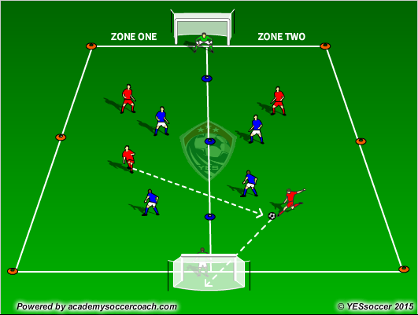
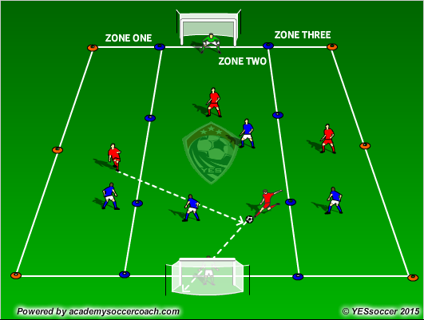
1/3 Pitch

Coaching Tips
At Baldwin Whitehall Soccer Association, our coaches are seen as role models and have a responsibility to provide a positive environment to nurture our players’ development both on and off the field. Below are a few coaching tips that our coaches use to help develop a positive environment for players to engage, develop and excel both in participating in soccer and their own personal development.
- Be an enthusiastic and passionate coach: When dealing with young players, first impressions can last a lifetime. Their behavior and interest in the game can be affected by the coach’s interaction with the players.
- Set a good example and be a role model: Coaching Soccer isn’t just about coaching the game, our coaches have a responsibility to help shape our players in their character development from childhood to adulthood.
- Provide an inclusive session and ensure that all players feel part of team: We want players to continue to be involved in soccer beyond childhood and into adulthood. We need to give them a positive and enjoyable experience of the game.
- Smile and provide plenty of praise during sessions: The enjoyment players get out of a session, the better learning and understanding they will gain from our sessions. This will result in them building up their confidence and self-esteem in the game.
- Rotate players and ensure each player gets a chance to participate in different roles and positions: The more roles and positions players are exposed to the more skills and better understanding of the game they will gain.
- Give ownership and responsibility to players during the sessions: Players will gain a deeper understanding of the game, if they take ownership for the direction of learning and make the learning experience more personal. Our coaches may do this by allowing players to come up with their own progressions of an activity, have group discussions on tactics they might employ during the activity, helping set up the equipment, ask and answer questions etc.
- Managing players’ differences as individuals: Each player is unique and requires different forms of player management. BWSA Coaches do this by getting to know the individual player, work on both their strengths and weaknesses, observe the players to see who need support and who needs challenging, and don’t complicate session (Keep it simple!)
- Cater to the different learning styles of players: In a session, there are always a wide range of different learning styles from Visual, Auditory and Kinesthetic. Our coaches provide a wide range of coaching styles to try cater to the different needs of our players, from some Command styles (to start a sessions) to Guided and Self Discovery coaching style. For example, a BWSA Coach may bring a portable whiteboard with the session plan drawn on and provide demonstrations (catering for Visual learners), while explaining the session verbally (Auditory learners) before finally allowing the players to play (Kinesthetic learners).
- Provide fun, engaging, motivational and age appropriate activities: In order for players to keep playing the game and turning up every week to training and matches, it is important that the activities are enjoyable and relatable to the players as much as possible. For example lots of young players play computer games, where the character they are playing has health/lives for the player to maintain or lose. In a BWSA session a player or team, may be given a certain amount of lives (represented visually by a line of cones for both teams) to maintain or lose and force an opposition team to lose. (See next page, showing the activity Dribble or Pass on how this may look in a session).

Dribble or Pass:
Red team tries to pass the ball to each other while the blue players (who are dribbling a ball each) are trying to get in the way of the passers or force the ball out of play. No tackling, no kicking the ball away by the blue team. (See diagram below).
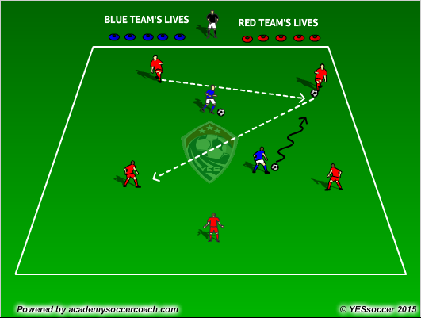
Team Lives Rule: When a Red team makes 3 or 5 consecutive passes, the Blue team loses a life. When Blues players interrupt the Red team’s passing (by getting in the way or forcing ball out play) the Red team loses a life.
This provides both teams with an objective to make the other team lose a life, before they lose a life of their own.
- RESPECT campaign: In order for everyone involved in at BWSA to enjoy being part of the Association, our coaches ensure that the ‘RESPECT campaign’ (see below) is evident in training sessions and matches. This is to make sure players display an appropriate attitude and behaviour commitment to making environment of the club enjoyable for all. If players fail to follow this procedure it will result in appropriate sanctions for their actions.
RESPECT |  | Myself, Other players, Coaches, Equipment, Supporters and Officials.
EFFORT |  | Put 100% effort into training, getting to sessions on time and personal play (during matches and training, regardless of winning or losing).
SUPPORT |  | Other players, coaches and helpers during matches & training to make it enjoyable for all involved.
PLAY |  | To play the best of your ability at all times.
ENJOY |  | Help everyone enjoy soccer by contributing to a positive atmosphere.
COMMIT |  | To RESPECT and you will help soccer to be a better place to achieve more.
TEAM |  | Do your BEST for the team to make others feel part of it.

At Baldwin Whitehall Soccer Association we aim to give the best possible environment, coaching and experience for all involved in our association. In order to improve our Under 6 program, we welcome feedback from players, coaches, parents and anyone involved within Baldwin Whitehall Soccer Association. Please print this page and hand it to a board member or copy, paste and email this page with your feedback on to help us improve coaching our under 6 players. Thank you for reading our Under 6 program and see you on the soccer field.
Feedback Form
Please state your involvement in Baldwin Whitehall Soccer Association: (Tick box)
Coach
Player
Parent
Board Member
Other
(Please state) ____________________________________

Any Additional Comments:
How can we improve the Baldwin Whitehall Soccer Association under 6s Program?:
Please rate how satisfied you are with the new Baldwin Whitehall Soccer Association under 6s Program: (Tick correct box, 1= Not satisfied at all, 3= Average, 5= Very Satisfied)

1 2 3 4 5
Please rate how useful you found the new Baldwin Whitehall Soccer Association under 6s Program: (Tick correct box, 1= Not Useful at all, 3= Average, 5= Very Useful)

1 2 3 4 5

